

Mini Project Report Gesture Based Media Control
Submitted by

JAYESH NAKUM (12202080601063)
KUNJ PATEL (12302080603007)
DARSHAN PARMAR (12102080601015)

In partial fulfillment for the award of the degree of

BACHELOR OF TECHNOLOGY
in
Information Technology A.D.Patel Institute of Technology

The Charutar Vidya Mandal (CVM) University, Vallabh Vidyanagar - 388120
April, 2025

A.D.Patel Institute of Technology
Mini Project

CERTIFICATE
This is to certify that the Mini Project Entitled “Gesture Based Media Control System” has been carried out by Jayesh Nakum (12202080601063), Kunj Patel (12302080603007), Darshan Parmar (12102080601015) under my guidance in partial fulfillment for the degree of Bachelor of Technology in Information Technology, A.D.Patel Institute of technology at The Charutar Vidya Mandal (CVM) University, Vallabh Vidyanagar during the academic year 2024 – 25.

Dr. Jayendrath Mangroliya Internal Guide

Prof. Trilok Suthar Dr. Narendrasinh Chauhan
Project Co-Ordinator Head of the Department

DECLARATION

I, Jayesh Nakum (12202080601063),Kunj Patel (12302080603007),

Darshan Parmar (12102080601015) hereby declare that Mini Project report submitted in partial fulfillment for the degree of Bachelor of Engineering/ Technology in Information Technology, A.D.Patel Institute of Technology, The Charutar Vidya Mandal (CVM) University, Vallabh Vidyanagar, is a bonafide record of work carried out by me under the supervision of Dr. Jayendrath Mangroliya and that no part of this report has been directly copied from any students’ reports or taken from any other source, without providing due reference.

Name of the Student Sign of Student

ACKNOWLEDGEMENT

We are extremely grateful to A. D. Patel Institute of Technology, CVM University for giving us the opportunity to work on the mini project titled " Gesture Based Media Control” We would like to express our heartfelt gratitude to our project guide, Dr. Jayendrath Mangroliya, for his constant support, guidance, and encouragement throughout the project. His valuable insights and timely feedback were crucial in shaping the project successfully.
We are also thankful to all the faculty members and the institute for providing the necessary infrastructure and resources that helped us complete the project work smoothly.
We extend our sincere thanks to our teammates Jayesh Nakum (12202080601063), Kunj Patel (12302080603009), Darshan Parmar (12102080601015) — for their collaboration, efforts, and teamwork during the entire project development process.

Team Members:
Jayesh Nakum (12202080601063)
Kunj Patel (12302080603009)
Darshan Parmar (12102080601015)

ABSTRACT

The evolution of human-computer interaction (HCI) has significantly advanced with the integration of natural and intuitive input methods. This project, "Gesture-Based Media Control System," introduces a novel approach to control media playback using hand gestures and voice commands—providing a touch-free, accessible, and user-friendly interface for everyday media applications.

Our system enables users to control media functions such as play, pause, forward, backward, mute, and unmute using either hand gestures or voice commands, with the unique ability to switch between these two modes dynamically. A major enhancement to the system is the support for voice commands in both English and Hindi, making it inclusive and practical for native language users.

Built using Python, the system leverages OpenCV and Mediapipe for real-time gesture recognition, while the SpeechRecognition library and Google Speech API are used for interpreting voice commands. The system dynamically responds to commands like “use gesture” or “use voice” to toggle between input modes, and “use Hindi” or “use English” to switch the language of voice input. The intuitive GUI interface displays real-time feedback about detected commands and active mode, further enhancing usability.
In conclusion, this system demonstrates the power of multimodal HCI and provides a foundation for future innovations.

List of Figures
Fig 1.1 A glimpse of system 1
Fig 1.2 Smart TV Gesture Control 4
Fig 1.3 Gesture Control in Medical 5
Fig 2.1 Current Media control System 6
Fig 2.7 Modules in system 10
Fig 3.1 System Design 12
Fig 3.2 Use Case 13
Fig 3.3 Activity Diagram 14
Fig 3.4 Interaction Overview 15
Fig 4.1.1 Play/Pause gesture 16
Fig 4.1.2 Mute/Unmute gesture 16
Fig 4.1.3 Forward/Backward gesture 17
Fig 4.1.4 Interface Design 17
Fig 4.2 Voice Command 18

List of Tables
Table 2.1 Limitation of current system 7
Table 2.6 Features of System 9
Table 5.1 Gesture Matrix 20
Table 5.2 Voice command Matrix 20

Abbreviations

Abbreviation | Full Form
GUI | Graphical User Interface
AI | Artificial Intelligence
ML | Machine Learning
CV | Computer Vision
NLP | Natural Language Processing
FPS | Frames Per Second
UI | User Interface
SDK | Software Development Kit
API | Application Programming Interface
OS | Operating System
CNN | Convolutional Neural Network
HCI | Human-Computer Interaction
VUI | Voice User Interface
ROI | Region of Interest
YOLO | You Only Look Once (Object Detection Algorithm)
RT | Real-Time
STT | Speech-to-Text
TTS | Text-to-Speech

Table of Contents

Acknowledgement | iv
Abbreviation | v
List of Figures | vi
List of Tables | vii
Abstract | viii
Table of Content | ix
Chapter 1 Introduction | 1
1.1 Problem Statement | 1
1.2 Project summary and introduction | 2
1.3 Aim and Objective | 3
1.4 Benefits | 4
1.5 Industrial Relevance | 4
1.6 Future Scope | 5
Chapter 2 System Analysis | 6
2.1 Study of current system | 6
2.2 Problem in current System | 7
2.3 Requirement of the new system | 8
2.4 System Feasibility | 9
2.5 Features of new system | 9
2.6 Main Modules | 10

Chapter 3 System Design | 12
3.1 System design and Methodology | 12
Chapter 4 Implementation | 16
4.1 Gestures | 16
4.1.1 Play/Pause | 16
4.1.2 Mute/Unmute | 16
4.1.3 Forward/Backwards | 16
4.1.4 Interface Design | 17
4.2 Voice Command | 18
Chapter 5 Testing | 19
5.1 Testing Plan | 19
5.2 Testing Analysis | 20
5.2.1 Gestur command confusion matrix | 20
5.2.2 Voice command confusion matrix | 20
Chapter 6 Conclusion | 22
References | 23

CHAPTER 1: INTRODUCTION

Problem Statement
Traditional media control systems rely heavily on physical input devices such as keyboards, mice, or remote controllers. These methods, while standard, are not always accessible or intuitive—especially in scenarios where the user’s hands are occupied or the user has mobility limitations. For example, someone cooking in the kitchen or working in a lab with gloves on may find it inconvenient to use conventional devices. Similarly, individuals with physical disabilities may struggle with fine motor control required for keyboard or mouse use. To address this issue, there is a need for an alternative, contactless system that leverages natural interactions like hand gestures or spoken commands for controlling media. A gesture and voice-enabled system not only provides a more natural way of interaction but also enhances accessibility and user experience in various environments.

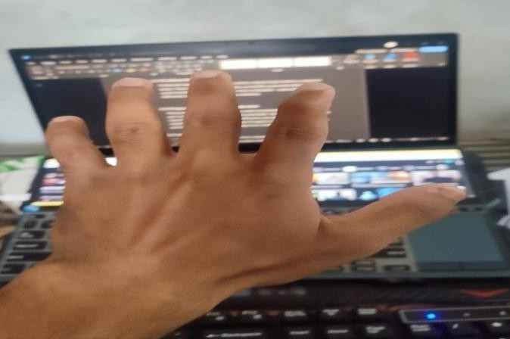
Fig 1.1 A glimpse of system
Image 1.1 shows a user interacting with a laptop using an open palm gesture in front of the webcam. This gesture is recognized by the system to either play or pause the media being displayed on the screen. The background shows a media player interface and a code editor running on the laptop, indicating that the system is active and functioning in real time.

Project Summary and Introduction
This project introduces a smart, real-time media control system that uses computer vision and natural language processing to interpret user commands through hand gestures and voice. Utilizing a standard webcam, the system identifies specific hand gestures such as an open palm for play/pause, a fist for mute/unmute, a right-hand thumb for forward, and a left-hand thumb for backward. The system also incorporates voice control functionality using speech recognition, capable of interpreting commands in both English and Hindi. A key highlight is the dynamic switching capability—users can switch from gesture mode to voice control and vice versa simply by saying “Use Voice” or “Use Gesture”.
The entire system is built in Python, leveraging OpenCV and Mediapipe for gesture recognition and Vosk or SpeechRecognition libraries for voice input processing. It provides a fluid and contactless interaction experience for controlling multimedia content, making it ideal for both personal use and integration into broader smart environments. Whether it's used in a home entertainment system, public information kiosk, or a smart classroom, the system is versatile, extensible, and user-friendly.

Aim and Objective
The primary goal of this project is to design and implement an intelligent media control interface that operates through hand gestures and voice commands, ensuring ease of use and accessibility. This system is aimed at improving human-computer interaction by introducing a more natural and inclusive method of controlling digital content.

The objectives include accurate recognition of hand gestures and voice commands to perform fundamental media operations such as play, pause, forward, backward, mute, and unmute. It supports dynamic language recognition to accept voice commands in both English and Hindi, thereby catering to a wider user base including non-English speakers. Another significant objective is to provide a seamless transition between gesture and voice-based control modes based on user preference or situational convenience. This adaptability contributes to a more responsive and personalized user experience.

In education, the system can support smart classrooms where instructors can control multimedia presentations through gestures or voice, reducing disruptions and increasing engagement. Additionally, in public information kiosks or museum exhibits, gesture and voice interaction can offer a more hygienic and interactive interface. Overall, this project aims to create a robust, contactless multimedia control solution that is practical, inclusive, and adaptable for real-world deployment.

Benefits
This system offers several important benefits. Most prominently, it enhances accessibility, making media control easier for individuals with physical disabilities or motor impairments who may not be able to use traditional devices. It also provides a hygienic alternative to shared input devices like remotes or keyboards—an important consideration in the wake of increased health and safety awareness. The dual-mode input system (gesture and voice) adds flexibility, ensuring the user can choose the most convenient method depending on the environment or situation.
The addition of multilingual voice support (English and Hindi) further improves usability for native language speakers, expanding inclusivity. The system is also hands-free, making it highly convenient in situations like cooking, driving, or multitasking where using a remote or keyboard is not feasible. Furthermore, as it uses readily available hardware (a webcam and microphone), it is a cost-effective and scalable solution.

Gesture and voice-based control systems find application across a wide variety of domains. In the domain of home automation, such systems enable users to control smart televisions, media players, and other connected devices without the need for physical remotes.
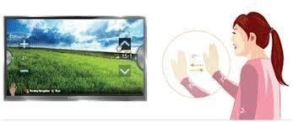

Fig 1.2 Smart tv Gesture Control

Image 1.2 referenced from https://www.samsung.com/lb/support/tv- audio-video/how-to-use-the-gesture-control-on-smart-tv/ illustrates a conceptual representation of gesture-based interaction with a smart display, reinforcing the relevance of this project in real-world applications. In the image, a woman is seen using hand gestures to interact with a smart television screen demonstrating commands such as volume control and channel navigation without physical contact.
In smart classrooms, educators can play, pause, or navigate educational videos using hand gestures or voice, creating a more interactive and distraction-free learning environment. In automotive systems, similar gesture controls are being introduced to reduce driver distraction by allowing control of music or calls with simple hand movements.

Furthermore, in public spaces like museums or information kiosks, gesture-based interfaces improve hygiene and user engagement by offering a touchless experience. The healthcare industry, too, can benefit from this technology doctors or lab technicians working in sterile environments can operate medical instructional videos or patient records without any physical contact.

Industrial Relevance
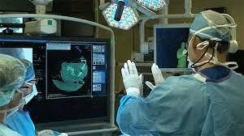
The concept of contactless media control has garnered significant attention in various industries. In manufacturing and industrial settings, gesture and voice systems can help workers interact with dashboards or instructional content without interrupting their workflow or removing safety gloves. In the entertainment and broadcasting industry, presenters can navigate content or control camera feeds during live sessions without the need for assistants or physical interfaces.

Fig 1.3 Gesture Control in Medicals

Image 1.3 referenced from https://www.sensortips.com/featured/how- can-a-machine-recognize-hand-gestures-faq/ highlights the use of gesture-based control in a medical environment, demonstrating the system's applicability in highly sensitive and critical settings such as operation theatres. In the image, a surgeon is interacting with a digital display showing medical scans without physically touching any equipment. The surgeon uses hand gestures to navigate or zoom into diagnostic images, maintaining sterility and avoiding cross- contamination.
Healthcare facilities can integrate such systems into operating rooms or diagnostic labs, where maintaining sterile conditions is crucial. Retail and hospitality industries can use such interfaces to allow customers to browse menus or promotional media at kiosks using gestures or voice, creating futuristic and interactive customer experiences. This technology aligns with the global movement toward smart environments and Industry 4.0, where human-computer interaction becomes more intuitive and seamless.

Future Scope
The current version of the system supports basic media controls, but it opens the door to numerous enhancements and real-world applications. In future iterations, more complex gestures can be introduced to support volume control, playlist navigation, or even launching applications. Integration with virtual assistants like Google Assistant or Amazon Alexa can enhance its utility further.

CHAPTER 2: SYSTEM ANALYSIS

Study of Current System
Current media control systems predominantly utilize physical interfaces such as keyboards, remote controls, touchscreens, or smart voice assistants like Alexa, Google Assistant, and Siri. While these systems have evolved over time, they still exhibit several limitations that affect their accessibility and flexibility. For instance, physical remotes and touch-based devices require the user to be within close proximity and have free hands to operate, which becomes a barrier for users with disabilities or when multitasking.
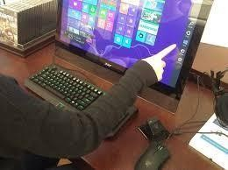

Fig 2.1 Current Media Control System

Reference- https://www.reddit.com/r/gaming/comments/195yv0/gaming_mouse_gaming
_keyboard_time_to_use_the/

Imag2.1referenced from shows a user operating a touchscreen interface on a desktop system. While effective for direct interaction, this method requires physical contact and may not be suitable for situations where hands are occupied, or hygiene is critical. It highlights the limitation of current systems that depend heavily on touch-based inputs.
Touchscreens may not be feasible in all scenarios, especially in environments like kitchens, hospitals, or industrial sites where hands may be occupied or unsanitary. Voice-controlled systems, though promising, face challenges such as language restrictions, accent recognition issues, and dependency on quiet environments or

strong network connectivity for accurate processing.

Moreover, most commercial systems do not support seamless switching between control modes (e.g., from gesture to voice or vice versa), which reduces user adaptability. There is also limited support for multilingual input, particularly for regional languages like Hindi, which makes them less inclusive for a diverse population. In terms of cost, advanced gesture recognition systems are either embedded in high-end smart TVs or require external sensors, making them less accessible to general users.
These limitations highlight the need for a more robust, intuitive, and accessible solution that supports contactless, multilingual, and real-time interaction with media systems—bridging the gap between convenience and inclusivity.

Problems in Current System
Table 2.2 Limitation of current systems

Traditional Input Method | Limitation
Keyboard / Mouse | Not feasible for hands-free or distant control
Remote Control | Easily misplaced or battery-dependent
Touchscreen | Impractical during multitasking or for disabled users
Voice-only Control | Language barrier, background noise interference
Gesture-only Control | May fail in low light or occlusion conditions
Table 2.2 summarizes the limitations of traditional input methods used for media control. It highlights how conventional tools like keyboards, remotes, and touchscreens lack adaptability in hands-free or multitasking scenarios. Voice-only and gesture-only systems, though modern, still face challenges such as language barriers, environmental noise, lighting conditions, or obstructions indicating the need for a more flexible and inclusive hybrid control system.

Requirements of the New System

The proposed gesture-based media control system with multilingual voice recognition aims to offer a more accessible and intelligent interface by eliminating the limitations of traditional input methods. One of the key requirements of this system is a standard webcam, which acts as the primary input device for gesture detection. The advantage of using a webcam is that it avoids the need for any specialized hardware like sensors or motion-capture gloves, making the solution highly cost-effective and easy to deploy on any basic laptop or desktop system.

Another core requirement is a Python environment, as the entire system is built using Python and several of its powerful libraries such as OpenCV for video processing, Mediapipe for real-time hand tracking, and SpeechRecognition for voice command handling. This environment should be capable of running real-time computer vision algorithms and audio processing tasks concurrently, ensuring a seamless user experience.

Real-time processing is essential for the effectiveness of the system. The system should respond immediately to user gestures or spoken commands to maintain natural and intuitive interaction. This necessitates a stable processor and efficient implementation of the algorithms to minimize delay between input detection and action execution.

Furthermore, the system must support multilingual speech processing, particularly in both English and Hindi. This increases the accessibility of the system to a broader range of users, especially in regions where English is not the first language. The ability to dynamically switch between languages through voice commands enhances the user experience and provides greater flexibility.

Lastly, a simple and responsive user interface is needed to provide interaction feedback to the user. This UI should indicate the current mode (gesture or voice), confirm recognized commands, and alert the user of any errors or switching actions. Such visual cues are important for usability and ensure that users feel in control of the system throughout their interaction.

System Feasibility

The feasibility of the proposed gesture and voice-based media control system can be evaluated across three major aspects: technical, operational, and economic.

From a technical perspective, the system is highly feasible because it utilizes hardware that is commonly available in almost every modern computing device—a standard webcam and a built-in or external microphone. There is no requirement for advanced or costly sensors, making the setup minimal and accessible.

Operational feasibility is also strong, as the system is designed to be user-friendly and intuitive. It allows users to control media playback using simple hand gestures or voice commands without needing to touch any device physically. The ability to switch between gesture and voice modes using voice input adds flexibility and enhances the user experience.

Economically, the system is highly feasible because it eliminates the need for purchasing additional hardware or proprietary software. It relies solely on open-source platforms, which significantly reduces development and deployment costs.

Features of new system
Table 2.5 Features of System

Features | Available
Play/Pause using Gesture | - Yes
Play/Pause using Voice (English) | - Yes
Play/Pause using Voice (Hindi) | - Yes
Switch between Gesture & Voice | - Yes
Switch between English & Hindi | - Yes
Forward/Backward Media | - Yes
Mute/Unmute | - Yes
GUI for Mode Display | - Yes
Offline Voice Recognition | - Yes
Real-time Feedback | - Yes

The table 2.5 summarizes the key features supported by the gesture and voice- based media control system. It highlights that the system successfully implements core media functionalities such as play, pause, mute, unmute, and forward/backward navigation through both gesture recognition and voice commands. Importantly, voice commands are supported in both English and Hindi, with the flexibility to switch between languages and control modes dynamically. The system also provides real-time feedback and includes a simple graphical user interface (GUI) that displays the current control mode. Furthermore, it operates offline, ensuring consistent performance without internet dependency.

()2.6 Main Modules





GUI
Display
Voice
Reognition
(English & hindi)
Mode
Switcher(if needed)
Gesture
Recognition
Media
Controled

Fig 2.6 Modules in system

The Fig 2.7 Main Modules presents a visual representation of the five essential components that collectively drive the gesture and voice-based media control system.

The first module, Gesture Recognition, is responsible for detecting and interpreting specific hand gestures captured via the webcam. This enables control of media actions such as play, pause, mute, unmute, forward, and backward based solely on hand movements.

The second module, Voice Recognition (English & Hindi), handles audio input from the user and translates spoken commands into actionable media controls. This bilingual functionality enhances accessibility and user convenience, especially for native Hindi speakers.

The third module, Mode Switcher, plays a critical role in toggling between gesture and voice control modes based on specific spoken commands such as “use gesture” or “use voice.”

Lastly, the GUI Display module provides a visual interface for feedback, indicating the current control mode (voice or gesture) and acknowledging received commands. This component enhances user experience by offering clear and immediate visual cues during system interaction.

Together, these interconnected modules form a robust, intuitive, and accessible media control system.

CHAPTER 3: SYSTEM DESIGN

3.1 System Design of Methodology

This diagram shows the architecture of a Gesture and Voice Based Media Controller system. It's organized into four main sections:
User Interaction: The top layer shows inputs from microphone (for voice commands), GUI interface (for manual control), and webcam (for capturing gestures). Input Processing: These inputs are processed by Voice Recognition and Gesture Recognition modules. There's also a Mode Switcher to toggle between control methods and a Language Switcher for voice commands.
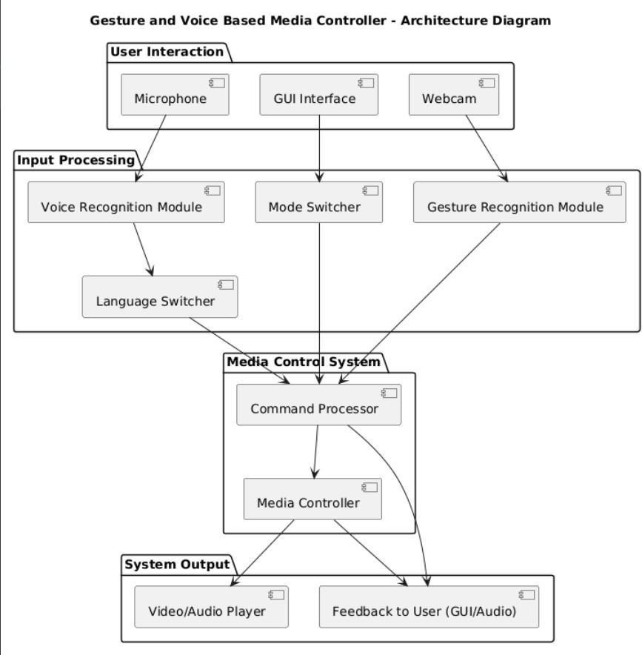
Media Control System: The core of the system has a Command Processor that interprets all inputs and a Media Controller that executes media playback functions. System Output: The bottom layer shows the Video/Audio Player that presents media content and a Feedback component that provides responses to the user through GUI or audio.

Fig 3.1 System Design

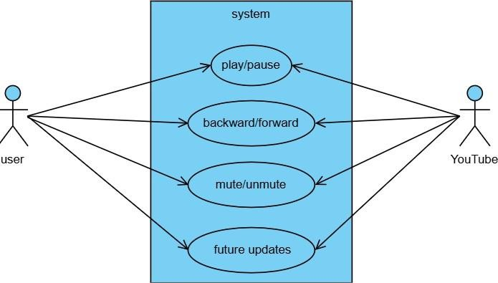
Fig 3.2 Use Case

This diagram shows a simple use case model for a media control system, specifically for YouTube. It illustrates:
Two actors: a "user" (left) and "YouTube" (right) Four main functions in the blue "system" area:
play/pause: Controls video playback backward/forward: Allows navigation within videos mute/unmute: Controls audio
future updates: Placeholder for planned features
The arrows indicate interactions between the actors and these functions. Both the user and YouTube can trigger or respond to these controls, showing bidirectional relationships.
Regarding the future updates section, you mentioned adding voice command features. This would allow users to control YouTube playback using spoken instructions instead of manual inputs. For example, users could say "play video," "pause," "skip forward," or "mute" to control playback hands-free. This would require implementing voice recognition technology to interpret commands and integrate them with the existing control functions.

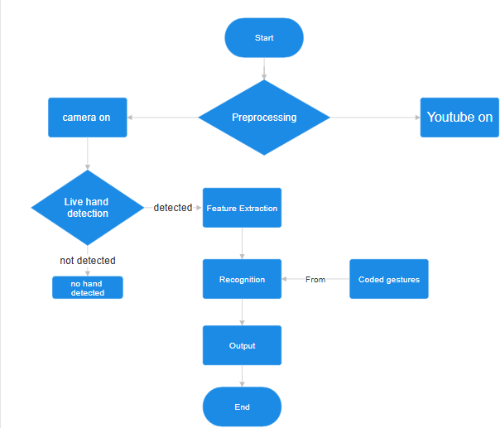

Fig 3.3 Activity Diagram

This flowchart illustrates the process flow of a gesture-based YouTube control system.
The process begins at the "Start" point and moves to a "Preprocessing" decision diamond. From there, the system simultaneously activates two components: "camera on" and "YouTube on," setting up the necessary tools for gesture recognition.
Once the camera is activated, the system enters a "Live hand detection" phase, which acts as a decision point. If no hand is detected, the system simply registers "no hand detected" and presumably continues monitoring. However, when a hand is detected, the process advances to "Feature Extraction," where the system analyzes the hand position and movement.
After extracting features, the system moves to the "Recognition" stage, which references "Coded gestures" from a separate component. This indicates that the system compares the detected hand positions against pre-programmed gesture patterns to determine what command the user is trying to execute.

After successfully recognizing a gesture, the system proceeds to "Output," where it presumably executes the corresponding YouTube command (such as play, pause, or volume control). Once the command is processed, the flow reaches its "End" point, though in practice the system would likely return to the hand detection phase to await further gestures.

This flowchart effectively demonstrates how gesture recognition technology could be implemented to control YouTube playback without requiring traditional input methods like a keyboard or mouse.

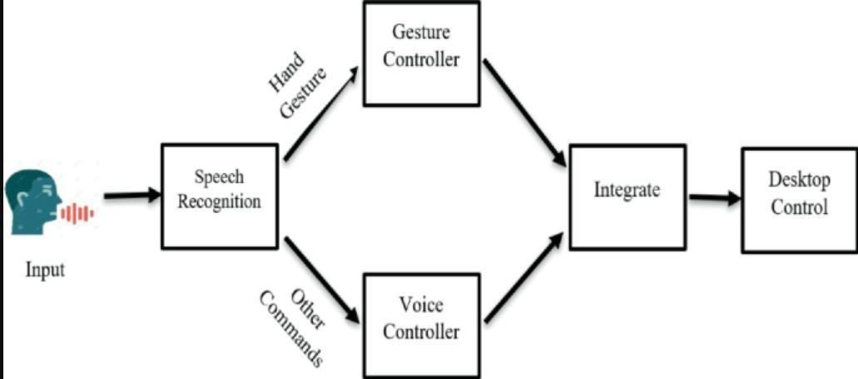

Fig 3.4 Interaction Overview of System

The fig 3.4 shows the interaction of user and system. User can Give command as per the need as want to go with gesture mode or with the voice command mode. As per the choice the system will reacts and gives the output.

Both controllers then connect to an "Integrate" component that combines these inputs. Finally, the integrated commands are sent to "Desktop Control," suggesting this system allows users to operate a computer using a combination of voice commands and hand gestures. The flowchart illustrates how speech and gesture inputs are processed separately before being integrated to provide comprehensive desktop control functionality.

CHAPTER 4: IMPLIMENTATION

Gestures

Paly Pause
The fig 4.1.1 shows how the user can play/pause their media. The hand has visible tracking or recognition markers outlining it, suggesting the system is detecting and analyzing the hand position. There appears to be code visible in the right panel, likely for implementing gesture controls.
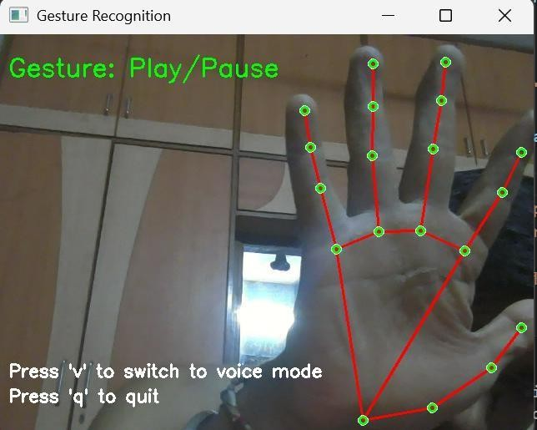
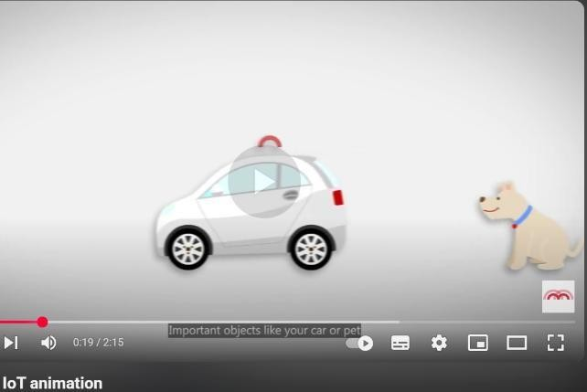

Mute/Unmute
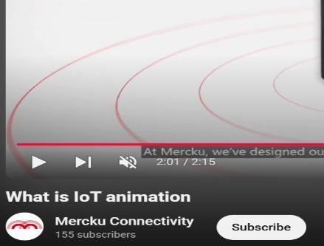
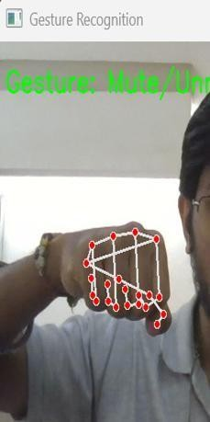
Fig 4.1.2 Mute/Unmute gesture

This fist gesture Fig 4.1.2 is programmed to toggle mute and unmute functions with a 2-second time interval between actions. This demonstrates another practical application of the gesture control system, where making a fist triggers audio muting/unmuting in the media player application.

Forward/Backward
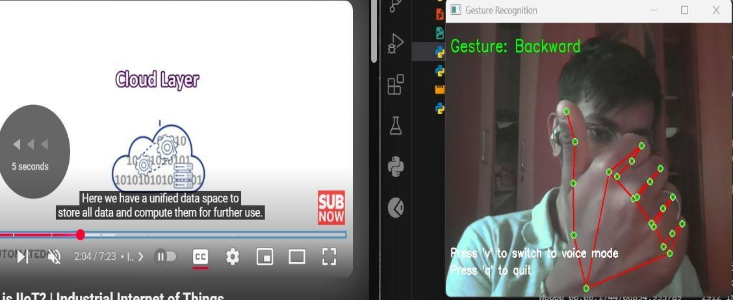

Fig 4.1.3 Forward/Backward gesture
This gesture see Fig 4.1.3 is being used for backward navigation in the media player, while a right-hand gesture (not shown in this image) would be used for forward navigation. At the bottom of the gesture recognition panel, there appears to be text indicating the user can "switch to voice mode" or "quit," showing that the system offers multiple interaction methods.
This demonstrates how the gesture control system can handle directional commands for media navigation in addition to the play/pause and mute/unmute functions shown in the previous images.

Interface Design
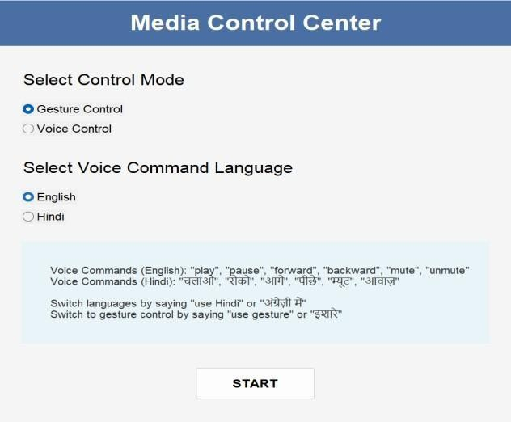
Fig 4.1.4 Gui interface of system

The image see Fig 4.1.4 shows a "Media Control Center" interface with configuration options for controlling media playback. At the top of the panel, users can select their preferred control mode, with "Gesture Control" currently selected over "Voice Control." Below this, there's a language selection section for voice commands, with "English" selected instead of "Hindi." The interface displays available voice commands in both languages - English commands include "play," "pause," "forward," "backward," "mute," and "unmute," while Hindi commands are shown in both Latin and Devanagari scripts. The panel also explains that users can switch between languages by saying "use Hindi" or the Hindi equivalent and can switch to gesture control mode by saying "use gesture" or its Hindi equivalent. At the bottom of the interface is a prominent "START" button to activate the selected control mode and settings.

Voice command
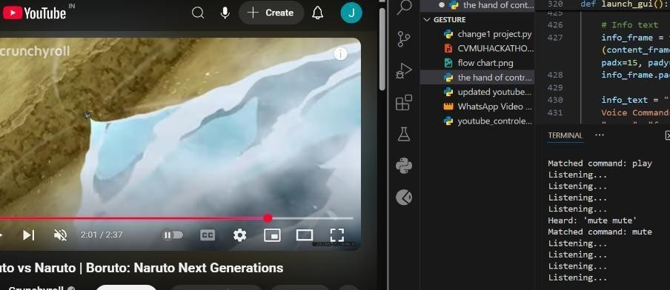
Fig 4.2 Voice command
The image showcases the voice command functionality of the multimedia control system in action. On the left side is a YouTube video player showing what appears to be content from Crunchyroll related to "Boruto: Naruto Next Generations" with standard YouTube playback controls visible at the bottom. On the right side is a development interface showing file directories and a terminal window that's actively processing voice commands. The terminal displays a sequence of operations where the system has detected voice input, with messages showing "Fetched command: play," "Listening..." repeated several times, followed by "Heard: 'mute mute'" and "Fetched command: mute."

CHAPTER 5: TESTING

Testing Plan
Integration testing focuses on verifying that different modules work correctly together. This would involve testing the connection between speech recognition and both controller modules, testing how the gesture and voice controllers feed into the integration component, and ensuring the system properly sends commands to desktop control. These tests would verify that data flows properly between components and that the communication protocols between modules function as designed.
Manual testing for multilingual voice accuracy is crucial for validating the system's language capabilities. Testers who are fluent in each supported language (English and Hindi based on the interface) would systematically test all voice commands in both languages, verifying pronunciation variations, accents, and speech patterns. This ensures the system can reliably recognize commands regardless of how users naturally speak in their preferred language, improving accessibility and user experience.
Stress testing under poor lighting/noisy conditions evaluates the system's resilience in challenging environments. For gesture recognition, testers would verify performance in low light, variable lighting, and with background movement. For voice recognition, testing would involve background noise, multiple speakers, and varying distances from the microphone. These tests ensure the system remains functional in real-world conditions where ideal circumstances aren't guaranteed, improving the overall robustness of the control system.
To ensure accessibility and ease of use across different demographics, usability testing will be conducted with diverse participants including technical and non-technical users, individuals of various ages, and people with different physical capabilities. Participants will complete standard tasks using both gesture and voice controls while researchers observe their interactions, noting any confusion, errors, or inefficiencies. Follow-up interviews will gather qualitative feedback about the intuitiveness of the interface, comfort with the gestures, clarity of voice command options, and overall satisfaction with the system.

Testing Analysis

Gesture Command Confusion Matrix
Table 5.2.1 Gesture Matix

Actual \ Predicted | Play | Pause | Forward | Backward | Mute | Unmute
Play | 18 | 1 | 0 | 0 | 0 | 1
Pause | 0 | 19 | 0 | 0 | 1 | 0
Forward | 0 | 0 | 20 | 0 | 0 | 0
Backward | 0 | 0 | 1 | 18 | 0 | 1
Mute | 0 | 0 | 0 | 0 | 20 | 0
Unmute | 0 | 0 | 0 | 1 | 0 | 19

Gesture Accuracy = (Correct Predictions / Total)
= (18+19+20+18+20+19) / (20×6) = 114 / 120 = 95%

Voice Command Confusion Matrix
Table 5.2.2 Voice command Matix

Actual \ Predicted | Play | Pause | Forward | Backward | Mute | Unmute
Play | 15 | 2 | 1 | 0 | 1 | 1
Pause | 1 | 14 | 1 | 1 | 2 | 1
Forward | 0 | 2 | 15 | 1 | 1 | 1
Backward | 0 | 0 | 2 | 14 | 1 | 3
Mute | 0 | 1 | 0 | 0 | 18 | 1
Unmute | 1 | 0 | 1 | 1 | 2 | 15

Voice Accuracy = (15+14+15+14+18+15) / 120 = 91 / 120 ≈ 75.83%

Average System Accuracy = (Gesture Accuracy + Voice Accuracy) / 2
= (95% + 75.83%) / 2 = 85.42%

This reflects real-world challenges: gesture recognition is more reliable due to clear visual cues, whereas voice recognition may suffer due to background noise, accent variations, and pronunciation differences.

To overcome the limitations associated with voice command recognition particularly those caused by background noise, accent diversity, and pronunciation variations—a multifaceted approach is necessary. Firstly, incorporating noise reduction algorithms such as spectral gating and Wiener filtering can significantly enhance the clarity of recorded speech, especially in environments with ambient noise. This helps in isolating the user's voice from unwanted background sounds, ensuring better accuracy during recognition.
Another effective strategy is to train the system using a diverse dataset that includes a wide range of accents, dialects, and speaking styles. This allows the model to generalize better and reduces bias towards specific language patterns. Additionally, the use of more advanced speech recognition models such as Google's Speech-to- Text API or offline models like VOSK or DeepSpeech can improve performance across languages. These models support keyword spotting and phoneme-level recognition, making them more adaptable to multilingual and accented speech.
Improving user interaction design can also contribute to better results. For example, adding visual or audio cues can notify users if their voice was not understood properly, prompting them to repeat or clarify the command. Moreover, offering a limited set of predefined voice commands—rather than complex or open-ended phrases—reduces ambiguity and improves the likelihood of accurate recognition.

Finally, enabling the system to switch between voice and gesture modes dynamically acts as a fail-safe. If the voice recognition fails due to noise or misinterpretation, the user can quickly resort to hand gestures for control.

CHAPTER 6: CONCLUSION

The gesture recognition component of the system effectively interprets specific hand movements and maps them to actions such as play, pause, volume up/down, mute/unmute, and media navigation (forward/backward). Meanwhile, the voice command module accurately detects spoken instructions and executes the corresponding actions with minimal delay. Together, these two modalities offer a robust, real-time, and hands-free control mechanism, enhancing the overall media interaction experience.
Despite the system's success, there remains significant room for enhancement and scalability. The following future improvements are recommended for extending the system's functionality and usability:
- Custom Gesture Training Per User: Implementing a personalized gesture training module would allow users to define their own gesture sets, improving comfort, accuracy, and control for individual preferences.
- Offline Voice Recognition: By integrating offline voice recognition models, the system can function without an active internet connection, enhancing privacy and reliability in remote or low-connectivity areas.
- Face Authentication for Secure Usage: Adding face recognition for user verification would introduce a layer of security, ensuring that only authorized users can interact with or alter the media control settings.
- Integration with Smart TVs or Android Systems: Expanding the system’s compatibility to support smart TVs and Android-based media devices would broaden its applicability, making it suitable for living rooms, classrooms, and conference settings.

REFRENCES

PAPERS
- Mitra S, Acharya T. “Gesture recognition: A survey.” IEEE Transactions on Systems, Man, and Cybernetics, Part C: Applications and Reviews, 37(3), 311–324, 2007.
- Potamitis I, Georgila K, Fakotakis N, Kokkinakis G. “An integrated system for smart-home control of appliances based on remote speech interaction.” Proceedings of Eurospeech, 2197–2200, 2003.

BOOKS

  - Bishop CM. In Pattern Recognition and Machine Learning; Springer, New York, pp 45–60, 2006.

  - Rabiner LR, Schafer RW. In Digital Processing of Speech Signals; Pearson Education, New Delhi, pp 200–215, 2004.

DISSERTATIONS

1. Nakum J., Mini-project report, “Gesture-Based Media Control System,” Gujarat Technological University, April 2024.

3 Parmar D., Mini-project report, “Multilingual Voice Command Integration for Media Player,” Gujarat Technological University, April 2024.

  - Patel K., Mini-project report, “Real-Time Media Controller using Python,” Gujarat Technological University, April 2024.

WEB SITES

- MathWorks, “Real-Time Object Detection with YOLO,” accessed on 8 February 2025, https://www.mathworks.com/help/vision/ref/yolov4.html
- Python Software Foundation, “SpeechRecognition Library,” accessed on 10 March 2025, https://pypi.org/project/SpeechRecognition/
- OpenCV, “Gesture Recognition with MediaPipe,” accessed on 15 March 2025, https://opencv.org/

PATENTS

- Rajasekaran M., System and method for controlling digital media using gesture and voice commands, Indian Patent Application No. 202141056789A, 2021.

